AI Tools Assignment: Mastering the AI Toolkit
Student: Adeyemi Ayorinde
Date: 10-Nov-2025
Part 1: Theoretical Understanding
- Explain the primary differences between TensorFlow and PyTorch.
Aspect | TensorFlow | PyTorch
Computation Graph | Static (TF 1.x) / Dynamic with TF 2.x | Dynamic by default (eager execution)
Use Case | Production-ready, deployment-focused | Research, prototyping, experimentation
Syntax | More verbose initially | Pythonic, intuitive
Community & Ecosystem | Large, many tools | Growing, very popular in academia
When to choose:
- TensorFlow: for deploying models to production (mobile, web, cloud)
- PyTorch: for research, quick experimentation, flexible dynamic models
2. Describe two use cases for Jupyter Notebooks in AI development.
- Experimentation and Prototyping:
Jupyter allows step-by-step testing of models, perfect for model experimentation and iterative development.
- Visualization and Documentation:
Markdown, equations, and plots (e.g., Matplotlib, Seaborn) can be combined with code to create interactive.
How does spaCy enhance NLP tasks compared to basic Python string operations?
- Built-in tokenization, POS tagging, and dependency parsing
- Named Entity Recognition (NER) for structured extraction
- Faster and more accurate than using raw Python string operations
- Supports custom pipelines and rule-based extensions

Comparative Analysis: Scikit-learn vs TensorFlow
Feature | Scikit-learn | TensorFlow
Target Applications | Classical ML (SVM, decision trees, regression) | Deep Learning (CNN, RNN)
Ease of Use | Beginner-friendly | Requires some DL knowledge
Community Support | Large, mature | Large, growing, many tutorials

Part 2: Practical Implementation
Task 1: Classical ML (Iris Dataset)
- Goal: Train a Decision Tree classifier and evaluate accuracy, precision, recall
- Code: Implemented in Jupyter Notebook (see notebook file)
- Screenshots:
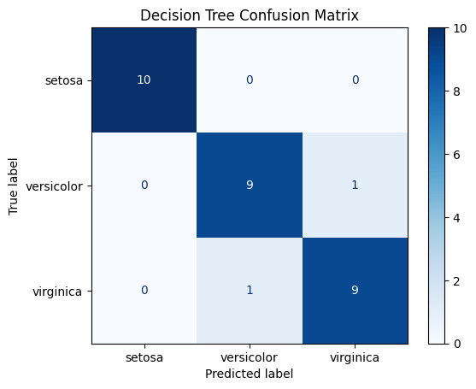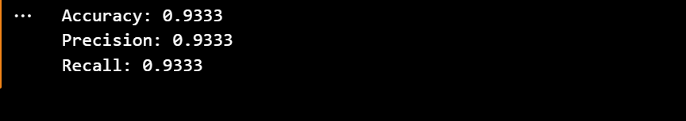

Task 2: Deep Learning (MNIST CNN)
- Goal: Build a CNN to classify handwritten digits (>95% accuracy)
- Code: Implemented in Jupyter Notebook
- Screenshots:
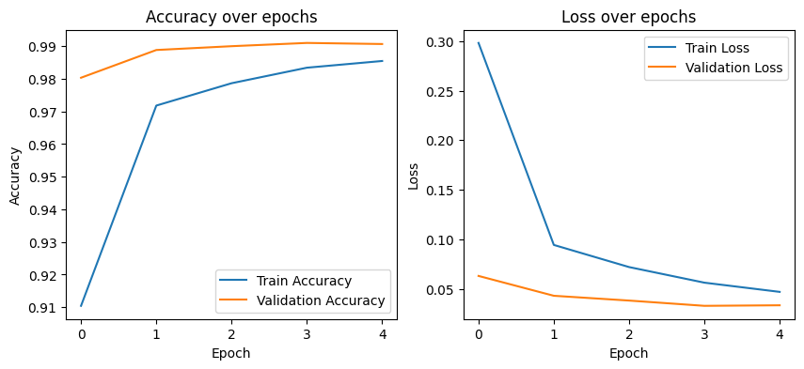
Training/validation accuracy and loss plots
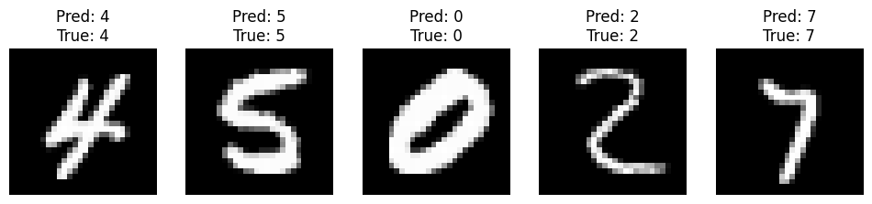
5 sample predictions with ground truth
Task 3: NLP with spaCy
- Goal: Named Entity Recognition (NER) and rule-based sentiment analysis
- Code: Implemented in Jupyter Notebook
- Screenshots:
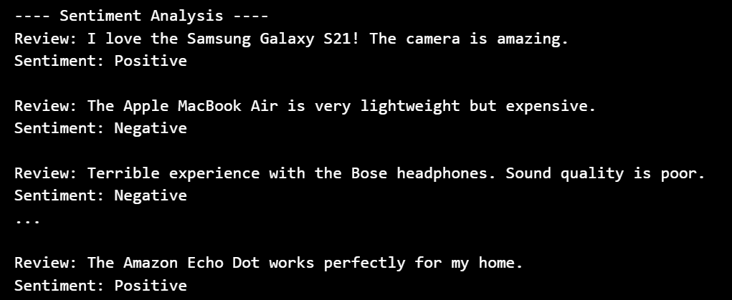
Extracted product names and brands
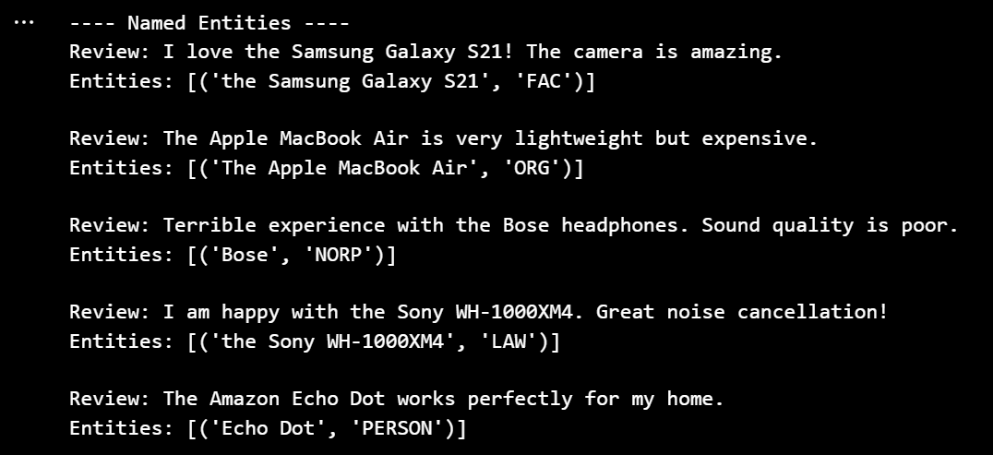
Sentiment analysis results for reviews
Part 3: Ethics & Optimization
Ethical Considerations
- Bias in MNIST: Certain digit styles may be underrepresented → model may misclassify unusual handwriting
- Bias in Reviews Analysis: Sentiment detection may fail for sarcasm or mixed reviews
- Mitigation:
  - Use TensorFlow Fairness Indicators to check for underrepresented data
  - Use rule-based extensions in spaCy to refine NER and sentiment detection
Troubleshooting Challenge
- Example: CNN dimension mismatch
- Solution: Reshape input images to (28,28,1) for Conv2D layers
- Always verify input shapes, loss functions, and activation functions

